LABORATORIYA ISHI 9

Mavzu:CSS Media Queries orqali responsiv dizayn yaratish

Ishning maqsadi
Web sahifalarni turli ekran o‘lchamlariga moslashadigan qilib yaratish.
Media queries qanday ishlashini o‘rganish.
Mobil, planshet va kompyuter ekranlari uchun moslashuvchan dizayn ishlab chiqish.
Responsiv dizayn yaratishda breakpointlardan foydalanish.
Real loyiha: “Kitob do‘koni” sahifasini mobilga moslash.
Ishning vazifalari
Media query nima va qayerda qo‘llanishini o‘rganish.
Ekran o‘lchamlarini aniqlash uchun breakpoints tanlash.
Mobil (≤600px), planshet (600–900px), desktop (900px+) dizaynni yaratish.
Flexbox/Grid elementlarini media so‘rovlari bilan moslashtirish.
“Kitob do‘koni” sahifasini turli qurilmalarda to‘g‘ri ko‘rinadigan qilish.
Nazariy qism
1. Responsiv (moslashuvchan) dizayn nima?
Responsiv dizayn — bu sayt ekran o‘lchamiga qarab shaklini o‘zgartiradigan dizayn turidir.
Bu degani:
telefon
Planshet
Noutbuk
katta monitor
hammasida sayt qulay ko‘rinadi.
2. Media queries nima?
Media query — bu CSS’ning maxsus qoidasi bo‘lib, u ma’lum shart bajarilganda stilni qo‘llaydi.
Masalan:
Ekran 600px dan kichik bo‘lsa -> mobil dizaynni qo‘llash.
Sintaksis:
@media (max-width: 600px) {
body {
background: yellow;
}
}
Bu kod faqat mobil ekranlarda ishlaydi.

3. Responsiv dizayndagi asosiy breakpointlar
Standart tarzda ishlatiladigan breakpointlar:
Qurilma | Ekran o‘lchami | Media query
Mobil | 0–600px | @media (max-width:600px)
Planshet | 600–900px | @media (max-width:900px)
Kompyuter | 900px dan katta | Normal CSS

4. Media queries’ning afzalliklari
Sayt barcha qurilmalarda to‘g‘ri ko‘rinadi
Mobil foydalanuvchilar uchun qulaylik
UX yaxshilanadi
SEO reytingi oshadi (Google mobilga mos saytlarni yaxshi baholaydi)

5. Media queries bilan qanday elementlar moslashtiriladi?
Rasmlar (width: 100%)
Menyu (mobil versiyada — burger menyu)
Ustunlar soni (3 ustun → mobilga 1 ustun)
Shript o‘lchamlari
Katta bo‘shliqlarni qisqartirish

Amaliy qism
Topshiriq: “Kitob do‘koni” sahifasini media queries yordamida responsiv qilish.
<!DOCTYPE html>
<html lang="uz">
<head>
<meta charset="UTF-8">
<title>Responsiv Kitob Do'koni - Yangi Dizayn</title>

<style>
body {
font-family: 'Trebuchet MS', sans-serif;
margin: 0;
background: linear-gradient(135deg, #e3f2fd, #fce4ec);
}

header {
text-align: center;
padding: 30px;
background: #6a1b9a;
color: white;
border-bottom-left-radius: 25px;
border-bottom-right-radius: 25px;
}

h1 {
margin: 0;
font-size: 36px;
}

.books {
display: grid;
grid-template-columns: repeat(3, 1fr);
gap: 25px;
padding: 35px;
}

.book {
background: white;
border-radius: 20px;
overflow: hidden;
box-shadow: 0 6px 18px rgba(0,0,0,0.2);
transition: 0.3s;
}

.book:hover {
transform: translateY(-8px);
box-shadow: 0 10px 22px rgba(0,0,0,0.25);
}

.book img {
width: 100%;
height: 240px;
object-fit: cover;
}

.content {
padding: 15px;
}

.title {
font-size: 22px;
color: #3e2723;
margin: 0;
}

.author {
font-weight: bold;
color: #6a1b9a;
margin-top: 5px;
}

.desc {
margin-top: 10px;
color: #4e342e;
line-height: 1.4;
}

/* 📱 MOBIL (max 600px) – 1 ustun, kichikroq shriftlar */
@media (max-width: 600px) {
.books {
grid-template-columns: 1fr;
}
header h1 {
font-size: 28px;
}
.book img {
height: 200px;
}
}

/* 📱 PLANShet (max 900px) – 2 ustun */
@media (max-width: 900px) {
.books {
grid-template-columns: repeat(2, 1fr);
}
}

</style>
</head>
<body>

<header>
<h1>📚 Yangi Responsiv Kitob Do'koni</h1>
<p>Media Queries asosida moslashuvchan dizayn</p>
</header>

<section class="books">

<div class="book">
<img src="https://images.unsplash.com/photo-1507842217343-583bb7270b66?auto=format&fit=crop&w=800&q=80
" alt="">
<div class="content">
<h3 class="title">Sehrli O'rmon</h3>
<p class="author">L. Anderson</p>
<p class="desc">Sehrli jonzotlar yashaydigan g‘aroyib o‘rmon haqida fantastik roman.</p>
</div>
</div>

<div class="book">
<img src="https://images.unsplash.com/photo-1509023464722-18d996393ca8?auto=format&fit=crop&w=800&q=80
" alt="">
<div class="content">
<h3 class="title">Yulduzlar Ostida</h3>
<p class="author">Sara Melvin</p>
<p class="desc">Ikki sayyohning hayotiy sinovlar orqali o‘tib borishi tasvirlangan.</p>
</div>
</div>

<div class="book">
<img src="https://images.unsplash.com/photo-1481627834876-b7833e8f5570" alt="">
<div class="content">
<h3 class="title">O'tmish Sirlari</h3>
<p class="author">D. Parker</p>
<p class="desc">Detektiv syujet asosida qurilgan, murakkab jumboqli hikoya.</p>
</div>
</div>

<div class="book">
<img src="https://images.unsplash.com/photo-1516979187457-637abb4f9353" alt="">
<div class="content">
<h3 class="title">Qalb So'zlari</h3>
<p class="author">Emma Rivers</p>
<p class="desc">Romantik janrdagi, o‘zaro tushunish va kechirish haqida yozilgan roman.</p>
</div>
</div>

<div class="book">
<img src="https://images.unsplash.com/photo-1495446815901-a7297e633e8d" alt="">
<div class="content">
<h3 class="title">Kodlar Saltanati</h3>
<p class="author">J. Morgan</p>
<p class="desc">Zamonaviy texnologiyalar va sun’iy aql rivoji haqida ilmiy fantastika.</p>
</div>
</div>

<div class="book">
<img src="https://images.unsplash.com/photo-1507842217343-583bb7270b66" alt="">
<div class="content">
<h3 class="title">Hayot Darslari</h3>
<p class="author">S. Nichols</p>
<p class="desc">Motivatsion, hayotiy saboqlar va inspiratsiya haqidagi kitob.</p>
</div>
</div>

</section>

</body>
</html>

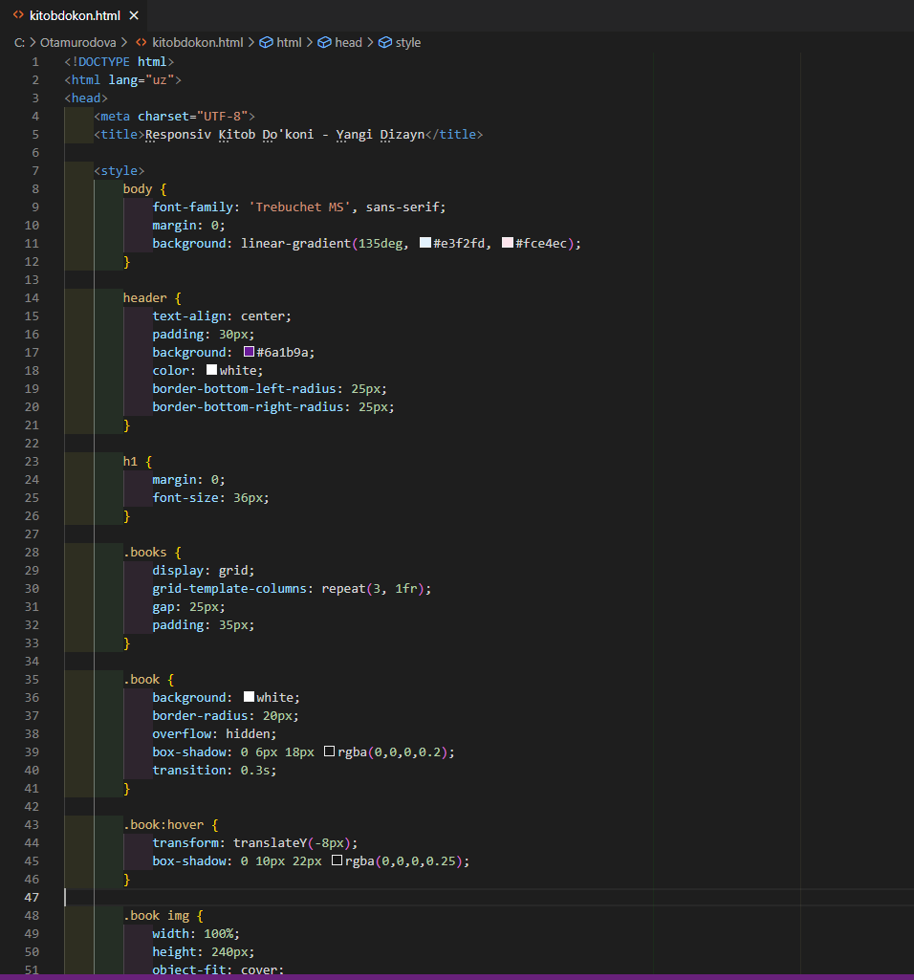
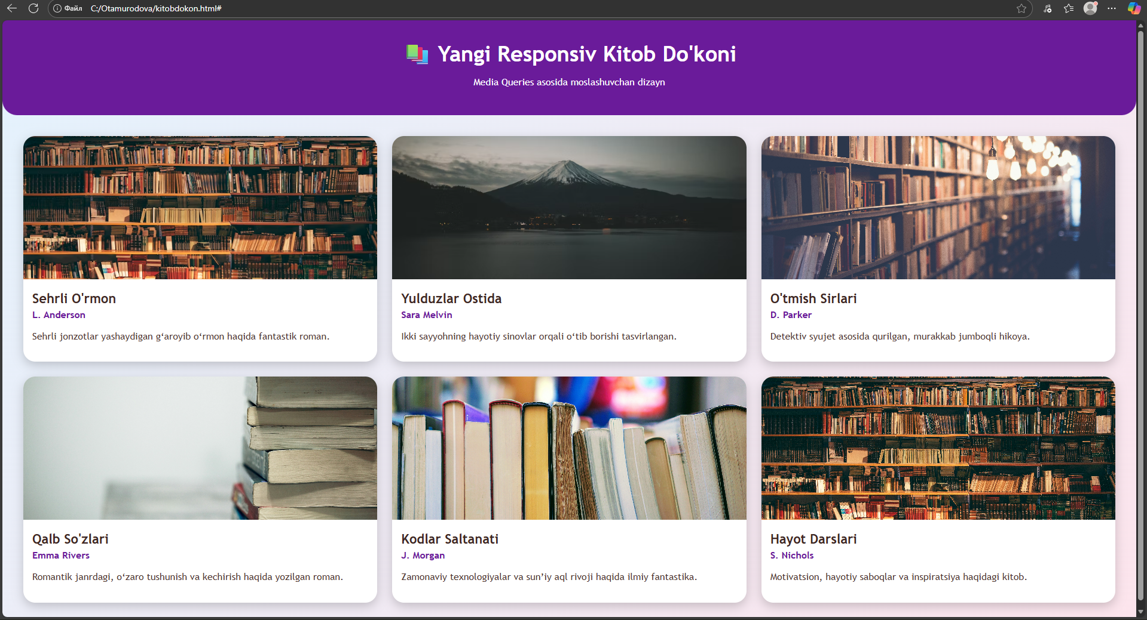

XULOSA
Ushbu laboratoriya ishida CSS media queries yordamida turli ekran o‘lchamlariga moslashuvchi — responsiv dizayn yaratish o‘rganildi. Media queries orqali sahifa strukturasini mobil, planshet va kompyuter uchun alohida moslashtirish, ustunlar sonini o‘zgartirish, shrift va bo‘shliqlarni optimallashtirish amaliy ko‘nikma hosil qilindi.
Responsiv dizayn zamonaviy web-saytlarning ajralmas qismi bo‘lib, foydalanuvchi tajribasini yaxshilaydi va saytning barcha qurilmalarda to‘g‘ri ishlashini ta’minlaydi. Ushbu laboratoriya natijasida talabalar media queries sintaksisi, breakpointlar va responsiv tartibni yaratish bo‘yicha mustahkam bilimga ega bo‘ldilar.

